Practical 1
Aim:-Write an application to create Calculator
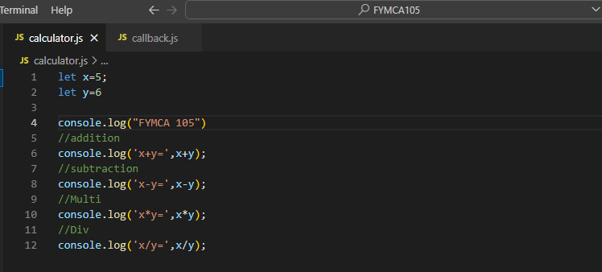
OUTPUT:-
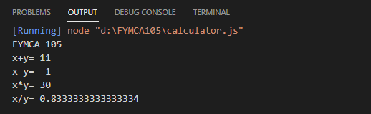

Practical:-2
Aim:- Write an application to Callback Function
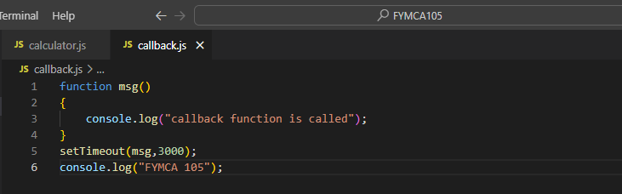

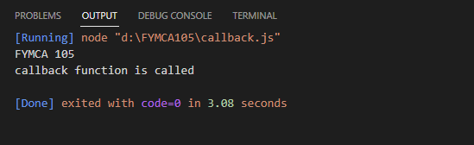

Practical:3
Aim:- Write an application to Arrow callback function
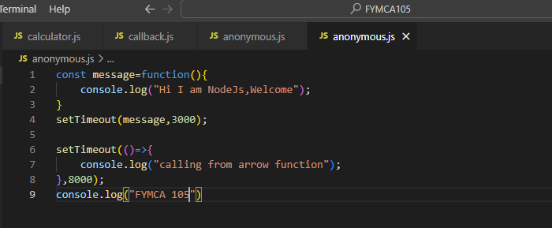
OUTPUT:-
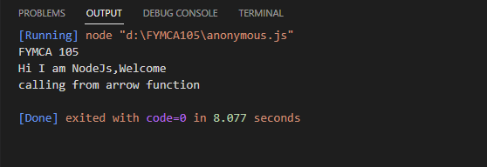

Practical 4
Aim:- Write an application to check a no is odd or even
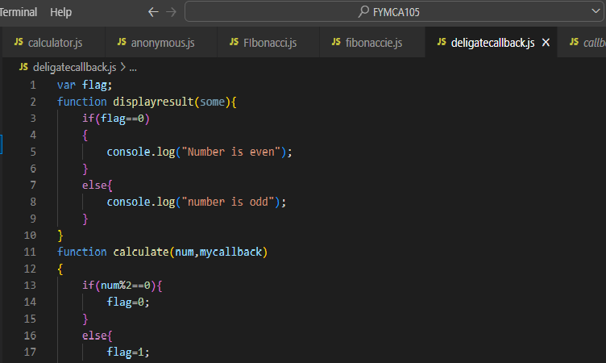
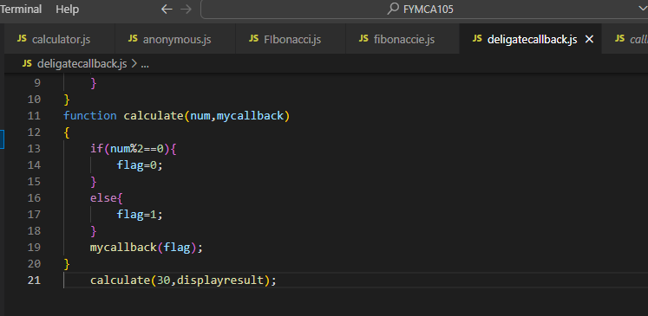

OUTPUT:-
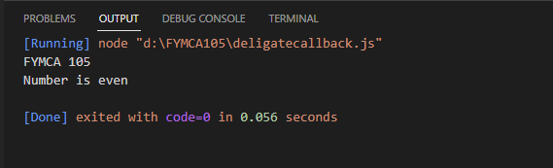

Practical :-5
Aim:- Write an application to display Fibonacci of 10 Number
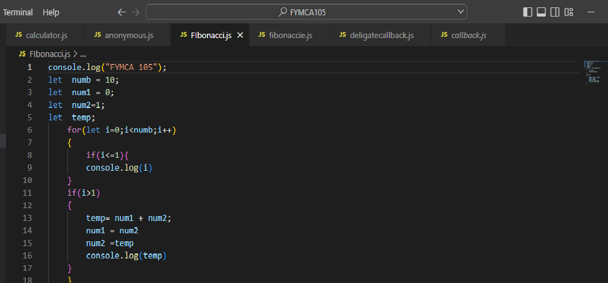
OUTPUT:-
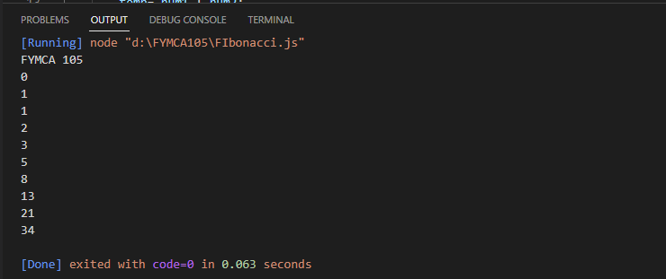

Practical:-6
Aim:- Write an application to Demonstrate Module
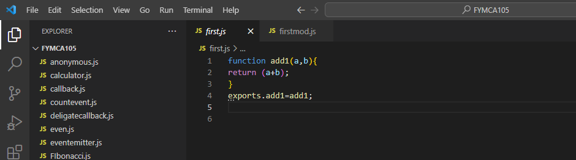
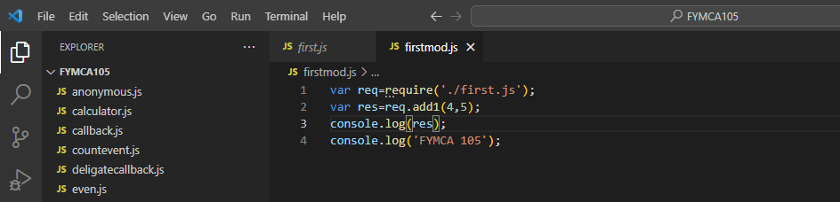
OUTPUT:
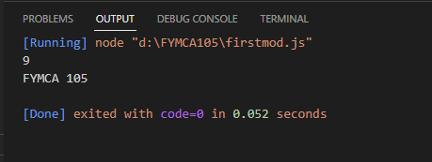

Practical:-7
Aim:- Write an application to find Perimeter of Circle,Rectangle & Square using modules

function add1(a,b){
return a+b;
}
exports.add1=add1;
//rectangle
function rect(l,b){
return 2*(l+b);

}
exports.rect=rect;

//square
function sq(a)
{
return 4*a;
}
exports.sq=sq;
//circle
function cir(r)
{
return 2*3.14*r;
}
exports.cir=cir;

OUTPUT:-
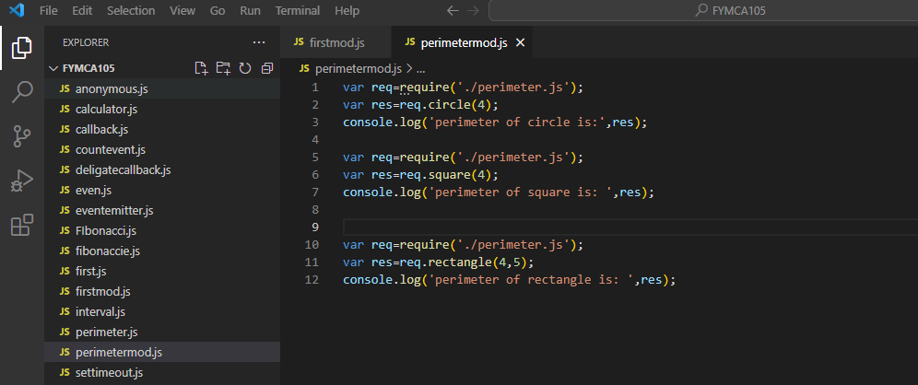

Practical:-8
Aim:- Write an application to display a message after 5 and 10 second respectively.
const myfun = delay=>{
console.log('Hello after'+delay+'seconds');
};
setTimeout(myfun,5000,'five');
setTimeout(myfun,10000,'ten');

OUTPUT:-
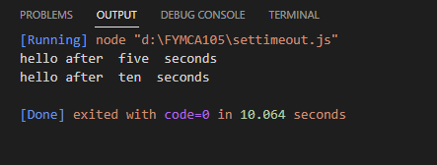

Practical:9
Aim: Write an application demonstrate set interval function.
setInterval(
()=>console.log("Hello after 4 seconds"),4000
);

Output:
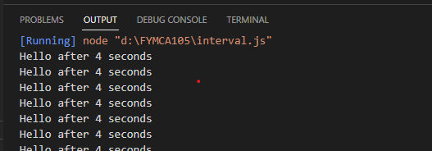

Practical:-10
Aim: Write an application demonstrate clearTimeout function
const myfun2=()=>console.log('cannot see');
const timeid = setTimeout(myfun2,0);
clearTimeout(timeid);

Output:
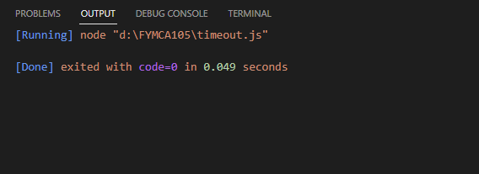

Practical:-11
Aim: Write an application to demonstrate EventEmitter
const EventEmitter = require('events');
const emitter = new EventEmitter();

//Register
emitter.on('messageLogged',function(){
console.log('Listner called');

});

//Raise
emitter.emit('messageLogged');

Output:
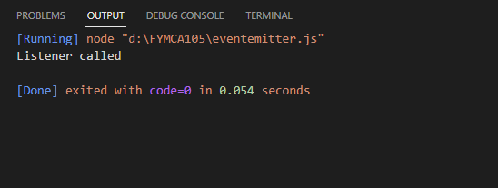

Practical:-12
Aim: Write an application to demonstrate Event types
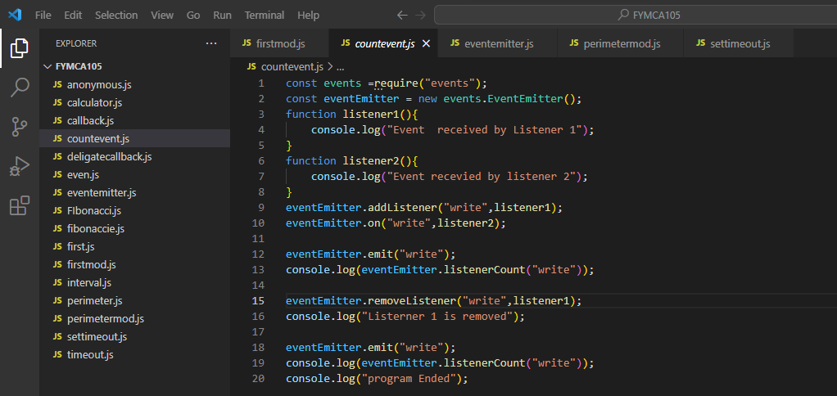
Output
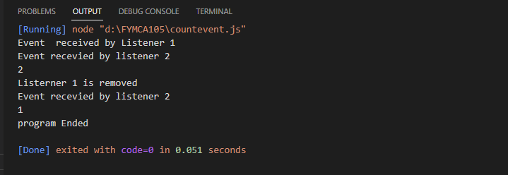

Practical:13
Aim:- Write an application to

var emitter = require('events').EventEmitter;
function LoopProcessor(num){

var e = new emitter()
setTimeout(function(){
for(var i = 1;i<=num;i++){
e.emit('BeforeProcess',i);
console.log('Processing number:'+i);
e.emit('AfterProcess',i);
}
},2000)
return e;
}
var lp =LoopProcessor(3);
lp.on('BeforeProcess',function(data){
console.log('About to start the process for'+data);
});
lp.on('AfterProcess',function(data){
console.log('Complete processing'+data)
});

Output:
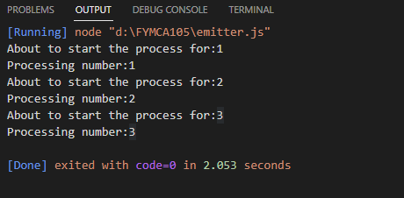
B)
var emitter=require('events').EventEmitter;
var util=require('util');
function LoopProcessor(num){
var me = this;
setTimeout(function(){
for(var i=1;i<=num;i++){
me.emit('BeforeProcess',i);
me.emit('AfterProcess',i);

}
},2000)
return this;}
util.inherits(LoopProcessor,emitter)
var lp = new LoopProcessor(3);
lp.on('BeforeProcess',function(data){
console.log('About to start the process for'+ data);
});
lp.on('AfterProcess',function(data){
console.log('Comepleted processing '+ data);
});

output:
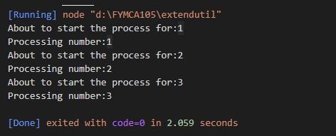

Practical:14
Aim:
Program:-
var http=require('http');
var server=http.createServer(function(req,res)
{
res.write('Shubham_105');
res.write('Hello Server');
res.end();

});
server.listen(5000);
console.log('web.js Web server at port 5000 is running..')

Output:-
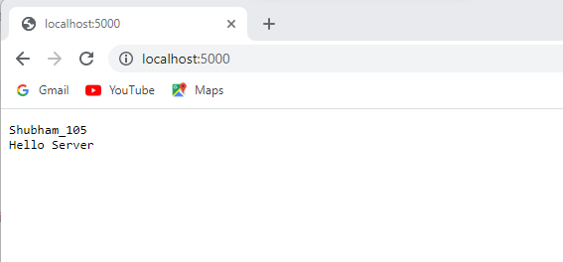

Practical:-15
Aim:-
Program
var http = require('http');
var server = http.createServer(function (req, res) {
if (req.url == '/home')
{
res.writeHead(200, { 'Content-Type': 'text/html' });
res.write('<html><h1> home</h1><body bgcolor="33F6FF"><p>this is Home Page</p><img src="flower.jpg" alt="Flowers Pic"><a href="/Admin">Admin</a><br><a href="/Student">Student</a><br></body></html>');
res.end();

}
else if (req.url == '/Admin')
{
res.writeHead(200, { 'Content-Type': 'text/html' });
res.write('<html><h1>Admin</h1><body bgcolor="B233FF"><p>this is Admin Page</p><a href="/Student">Student</a><br><a href="/home">home</a><br></body></html>');
res.end();
}
else if (req.url == '/Student')
{
res.writeHead(200, { 'Content-Type': 'text/html' });
res.write('<html><h1>Student</h1><body bgcolor="93FF33"><p>This is Student Page</p><a href="/home">Home</a><br><a href="/Admin">Admin</a><br></body></html>');
res.end();
}
else
res.end('Invalid Request!');

});
server.listen(5500);
console.log('Node.js web server is shubham_105 running')

Output:

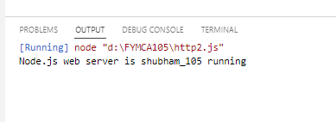

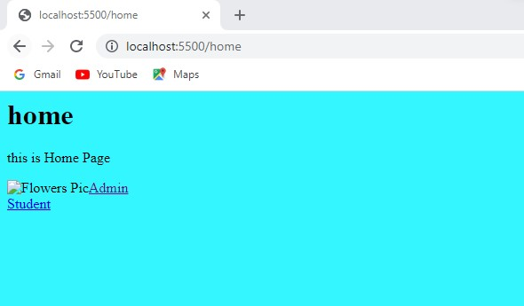
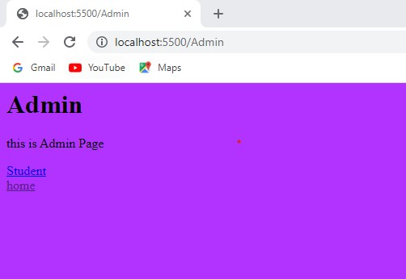

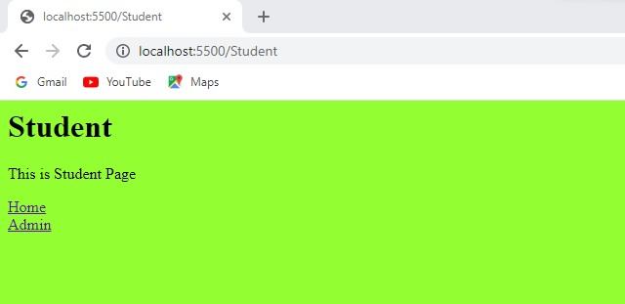

Practical :-16
Aim
Program:
const path = require("path");
const pathobj = path.parse(__filename)
console.log(pathobj)

Output:
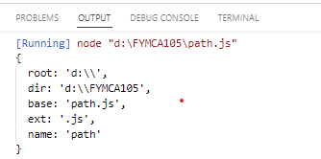

Practical:-17
Aim:
Program:-
const fs =require("fs");
fs.readFile("path.js",function(err,data){
console.log("readfile");
console.log(data);

});

Output:
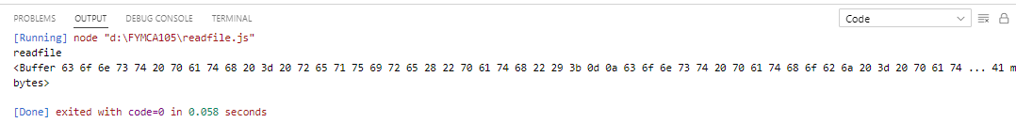

Practical:18
Aim:
Program:-
const fs =require("fs");
fs.writeFile('shubham.txt','hello sir its good to see you again',function(err,data){
console.log("writing");
});

Output:
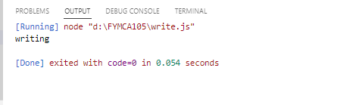
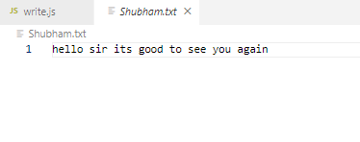

Practical:-19
Aim:
Program:
const fs =require("fs");
fs.appendFile('shubham.txt','hello sir its good to see you again',function(err,data){
console.log("Shubham_105");
console.log("appendFile");
});

Output:
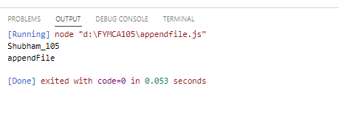
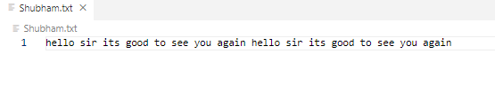

Practical:-20
Aim
Program:-
const fs =require("fs");
fs.rename("hello.txt","Shubham.txt",function(err,data){
console.log("renamefile")

});

Output:
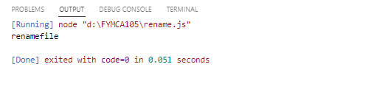

Practical:-21
Aim:
Program:
const fs =require("fs");
fs.unlink("Shubham.txt",function(err,data){
console.log("File delete")

});

OUTPUT:
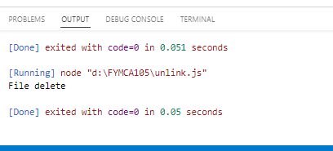

Practical:-22
Program:
var mysql=require('mysql');
var con=mysql.createConnection
({
host:'localhost',
user:'root',
password:""
});
S
con.connect(function(err){
if(err) throw err;
console.log("Connected");
con.query("Create database RollNo_105",function(err,result){
if(err) throw err;
console.log("database Create");
});
});

OUTPUT:-
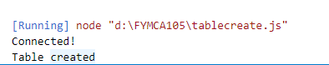

PRACTICAL:-TABLECREATION

Program:-
let mysql=require("mysql");
let con =mysql.createConnection({
host:"localhost",
user:"root",
password:"",
database:"rollno_105"
});
con.connect(function(err) {
if (err) throw err;
console.log("Connected!");
let sql = "CREATE TABLE Faculty (fac_name VARCHAR(255), fac_designation VARCHAR(255),fac_mobile INT(10),fac_subject VARCHAR(255),fac_salary INT(255) )";
con.query(sql, function (err, result) {
if (err) throw err;
console.log("Table created");
});
});

OUTPUT:-

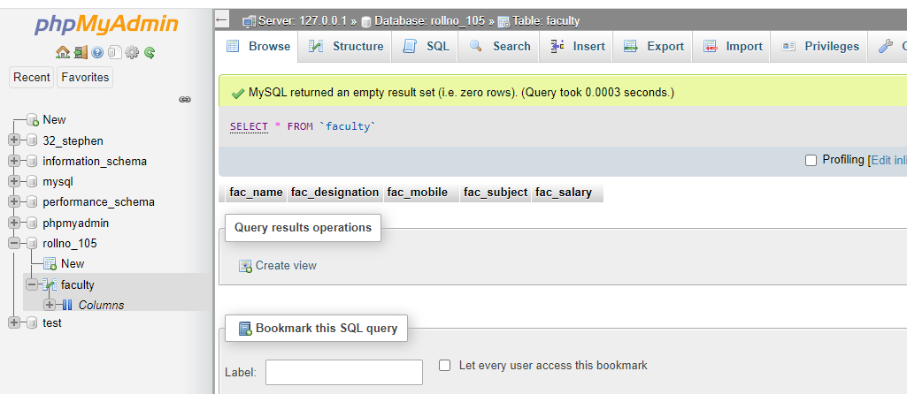
Practical:-InsertTable
Program:-
let mysql=require("mysql");
let con =mysql.createConnection({
host:"localhost",
user:"root",
password:"",
database:"rollno_105"
});
con.connect(function(err) {
if (err) throw err;
console.log("Connected!");
var sql = `INSERT INTO Faculty (fac_name ,fac_designation,fac_mobile ,fac_subject,fac_salary) VALUES
('Rahul','Professor','6654851520','Advance Java','100000'),
('Seema','Professor','8534416332','Web Technology','100000'),
('Murlidhar','Professor','9634513232','Software Project Management','100000')
` ;
con.query(sql, function (err, result) {
if (err) throw err;
console.log("Record inserted");
});
});

OUTPUT:-
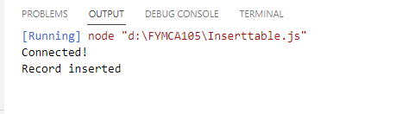

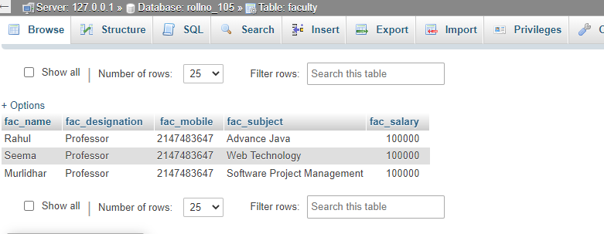

Practical:-Display
Program:
let mysql=require("mysql");
let con =mysql.createConnection({
host:"localhost",
user:"root",
password:"",
database:"rollno_105"
});
con.connect(function(err) {
if (err) throw err;
con.query("SELECT * FROM Faculty", function (err, result, fields) {
if (err) throw err;
console.log(result);
});
});

OUTPUT:
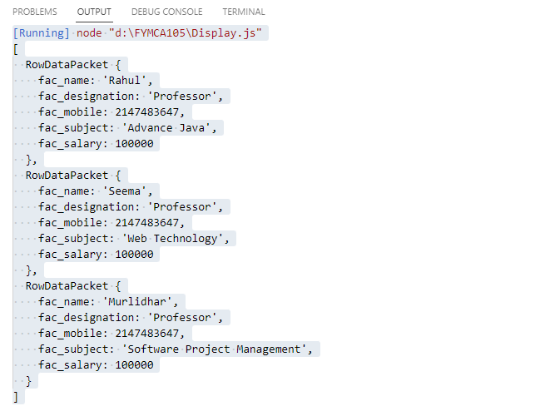
Practical:Update
Program:
let mysql=require("mysql");
let con =mysql.createConnection({
host:"localhost",
user:"root",
password:"",
database:"rollno_105"
});
con.connect(function(err) {
if (err) throw err;
var sql = "UPDATE Faculty SET fac_salary = '250000' WHERE fac_name = 'Rahul'";
con.query(sql, function (err, result) {
if (err) throw err;
console.log(result.affectedRows + " record(s) updated");
});
});
OUTPUT:-
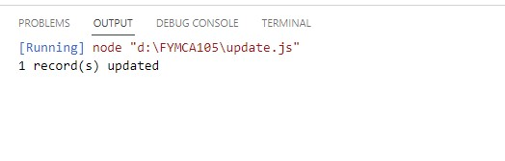
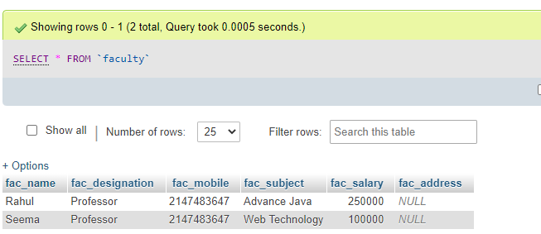

Practical:-Alter Table
Program:
let mysql=require("mysql");
let con =mysql.createConnection({
host:"localhost",
user:"root",
password:"",
database:"rollno_105"
});
con.connect(function(err) {
if (err) throw err;
var sql = `ALTER TABLE faculty ADD fac_address varchar(255);`;
con.query(sql, function (err, result) {
if (err) throw err;
console.log("column added");
});
});

OUTPUT:-


DELETE RECORD
Program:
let mysql=require("mysql");
let con =mysql.createConnection({
host:"localhost",
user:"root",
password:"",
database:"rollno_105"
});
con.connect(function(err) {
if (err) throw err;
var sql = `DELETE FROM faculty WHERE fac_name='Murlidhar';`;
con.query(sql, function (err, result) {
if (err) throw err;
console.log("record delete");
});
});

OUTPUT:-
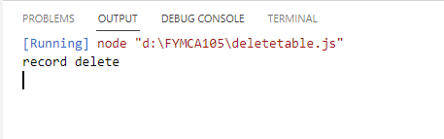

ANGULARJS:-

<!DOCTYPE html>
<html lang="en">
<head>
<meta charset="UTF-8">
<meta http-equiv="X-UA-Compatible" content="IE=edge">
<meta name="viewport" content="width=device-width, initial-scale=1.0">
<title>Document</title>
<script src="angular.min.js"></script>
</head>
<body ng-app="">
<div ng-init="arr1=[0,10,20,100,20]">
<p>First element:{{arr1[0]}}</p>
<p>Third element:{{arr1[3]}}</p>
<p>Fourth element:{{arr1[4]}}</p>
</div>
</body>
</html>

OUTPUT:-
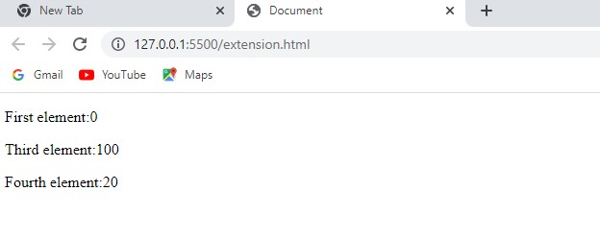

ANUGULARJS
Extension2
<!DOCTYPE html>
<html lang="en">
<head>
<script src ="angular.min.js"></script>
<meta charset="UTF-8">
<meta http-equiv="X-UA-Compatible" content="IE=edge">
<meta name="viewport" content="width=device-width, initial-scale=1.0">
<title>Document</title>
</head>
<body>
<div ng-app="" ng-init="arr1=[{fruit:'apple',color:'red'},{fruit:'orange',color:'orange'}]">
<ol>
<li ng-repeat="i in arr1">
{{ i.fruit +','+ i.color}}
</li>
</ol>
Addition={{2+5+10}}
</div>
Substraction = {{100-20}} <!--this will not run-->
</body>
</html>

OUTPUT:
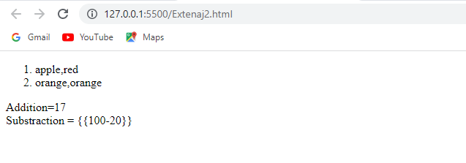

Practical:an3
Program:
<!DOCTYPE html>
<html lang="en">
<head>
<meta charset="UTF-8">
<meta http-equiv="X-UA-Compatible" content="IE=edge">
<meta name="viewport" content="width=device-width, initial-scale=1.0">
<title>Document</title>
<script src="angular.min.js"></script>
<style></style>
</head>
<body style=" background-image: linear-gradient(
#fb92ff,#005661); font-size: 30px; background-repeat: no-repeat; height: 100vh; font-family: sans-serif;">
<div ng-app="" ng-init="arr=[{sub:'Java',marks:45},{sub:'Web-Technology',marks:55},{sub:'Spm',marks:65},{sub:'Adbms',marks:55}]" style="text-align: center; width: 500px; margin:0 auto;">
<p>NCRD's Sterling Institute of Management</p>
<p>Name-Shubham Navale</p>
<p>Roll no-105</p>
<ol>
<li ng-repeat="i in arr" >
{{"Marks in "+i.sub+' is '+i.marks}}
</li>
</ol>
</div>
</body>
</html>
OUTPUT:
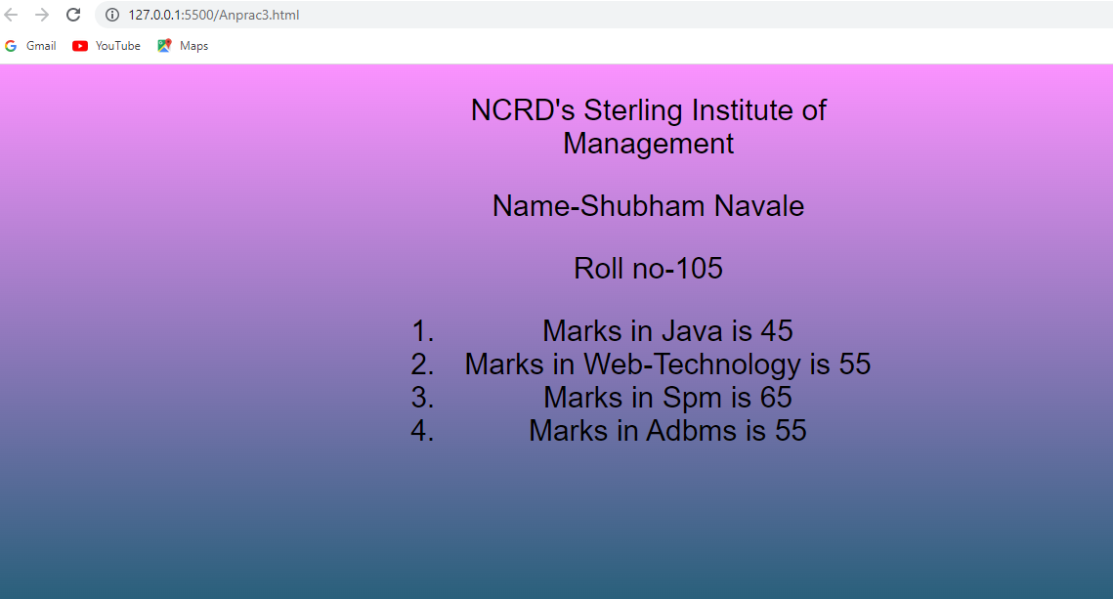
Practical:
<!DOCTYPE html>
<html lang="en">
<head>
<meta charset="UTF-8">
<meta http-equiv="X-UA-Compatible" content="IE=edge">
<meta name="viewport" content="width=device-width, initial-scale=1.0">
<title>Document</title>
<script src="angular.min.js" ></script>
</head>
<body>
<div ng-app="" ng-init="color:'red'">
color=<input style="background-color: {{color}}" ng-model='color'>
</div>
</body>
</html>
OUTPUT:-
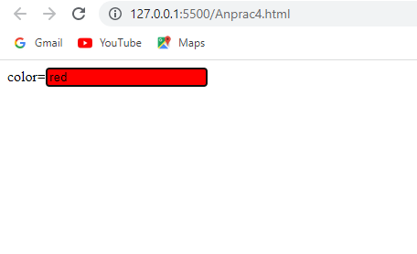

SimpleInterates:
<!DOCTYPE html>
<html lang="en">
<head>
<meta charset="UTF-8">
<meta http-equiv="X-UA-Compatible" content="IE=edge">
<meta name="viewport" content="width=device-width, initial-scale=1.0">
<title>Document</title>
<script src="angular.min.js"></script>
</head>
<body>
<h1>To Calculate simple interest</h1>
<div ng-app ng-init="amount=0; rate=0; time=0;">
<form action="">
<label for="number">Enter Amount</label><br>
<input type="number" name="number" id="number" ng-model="amount"><br>
<label for="rate">Rate</label><br>
<input type="number" name="rate" id="rate" ng-model="rate"><br>
<label for="number">Year</label><br>
<input type="number" name="year" id="year" ng-model="year">
</form>
<p>Simple Interest is {{ (amount * Year * rate) / 100 }}. </p>
</div>
</body>
</html>
OUTPUT:
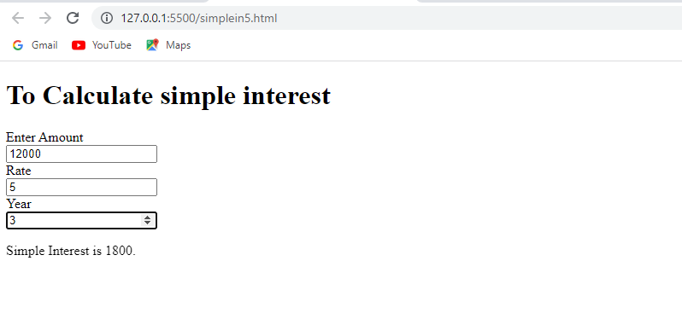

Practical 7 angular

<!DOCTYPE html>
<html lang="en">
<head>
<meta charset="UTF-8">
<meta http-equiv="X-UA-Compatible" content="IE=edge">
<meta name="viewport" content="width=device-width, initial-scale=1.0">
<title>105</title>
<script src="angular.min.js" ></script>
</head>
<body ng-app ng-init="checked=true">
Click Me:<input type="checkbox" type="text" ng-model="checked"><br/>
<div>
New:<input ng-if="checked" type="text">
</div>
<div>
Read-only:<input ng-readonly="checked" type="text" value="This is read-only">
</div>
<div>
Disabled:<input ng-disabled="checked" type="text"
value="This is Disabled">
</div>
</body>
</html>

OUTPUT:-

